|  |  |
| --- | --- |
| Name: Davila, John E. | Instructor: Mr. Alfred Ocampo |
| Section: BSIT – 2D | Subject: FDBS |

Activity #2

Table of Contents

**Fundamental of Database Systems** 2

Min and Max 2

The MIN() function returns the smallest value of the selected column. 2

The MAX() function returns the largest value of the selected column. 3

Count Ave Sum 4

The COUNT() function returns the number of rows that matches a specified criterion. 4

The AVG() function returns the average value of a numeric column. 5

The SUM() function returns the total sum of a numeric column. 6

Like 7

The LIKE operator is used in a WHERE clause to search for a specified pattern in a column. 7

In 9

The IN operator allows you to specify multiple values in a WHERE clause. 9

Between 10

The BETWEEN operator selects values within a given range. The values can be numbers, text, or dates. 10

# **Fundamental of Database Systems**

## Min and Max

### The MIN() function returns the smallest value of the selected column.

#### **Before using MIN()**

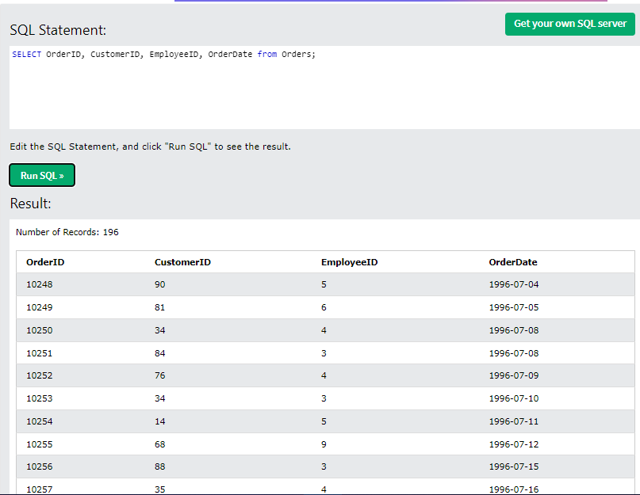

#### **After using MIN()**

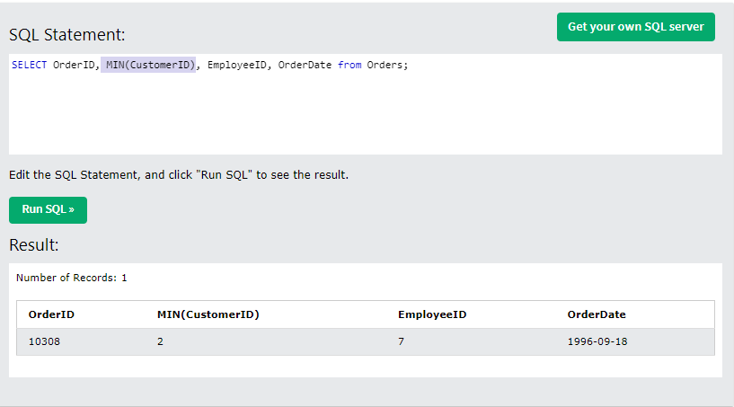

### The MAX() function returns the largest value of the selected column.

#### **Before using MAX()**



#### **After using MAX()**

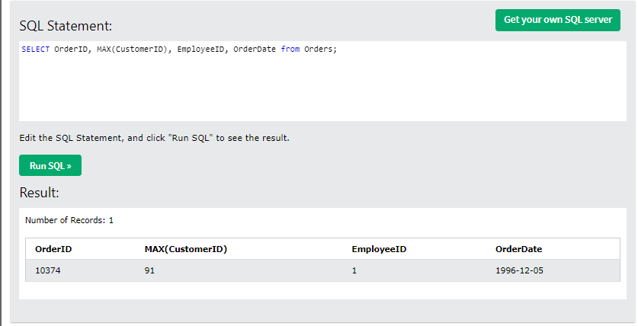

## Count Ave Sum

### The COUNT() function returns the number of rows that matches a specified criterion.

#### **Before using COUNT()**

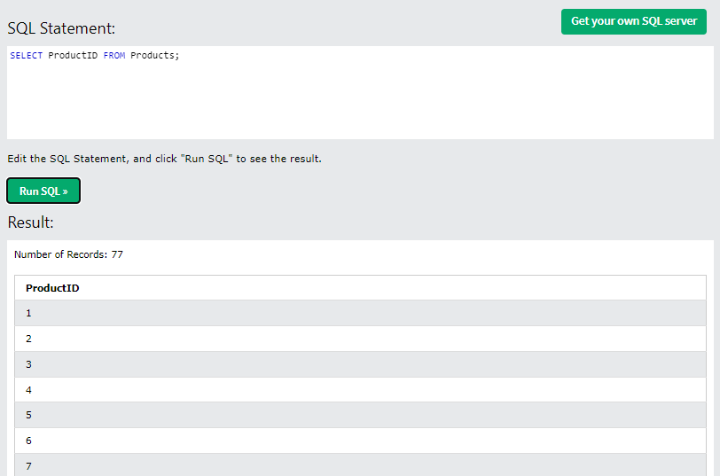

#### **After using COUNT()**

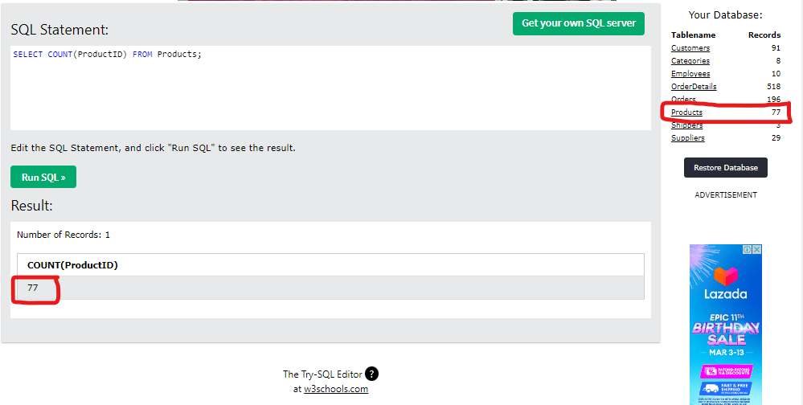

### The AVG() function returns the average value of a numeric column.

#### **Before using AVG()**

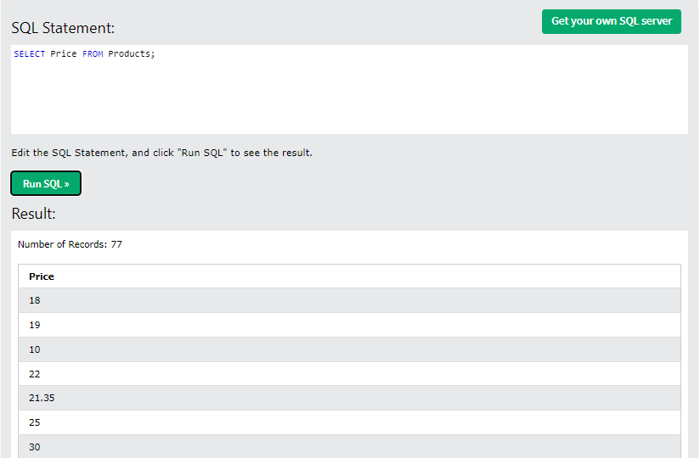

#### **After using AVG()**

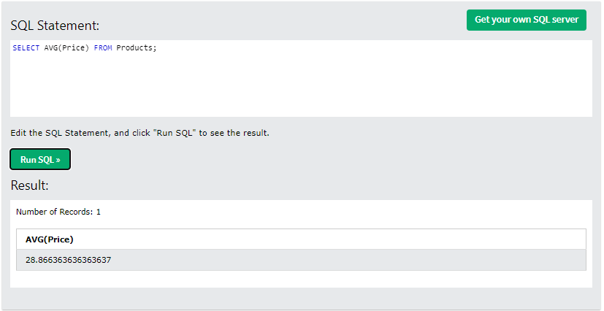

### The SUM() function returns the total sum of a numeric column.

#### **Before using SUM()**

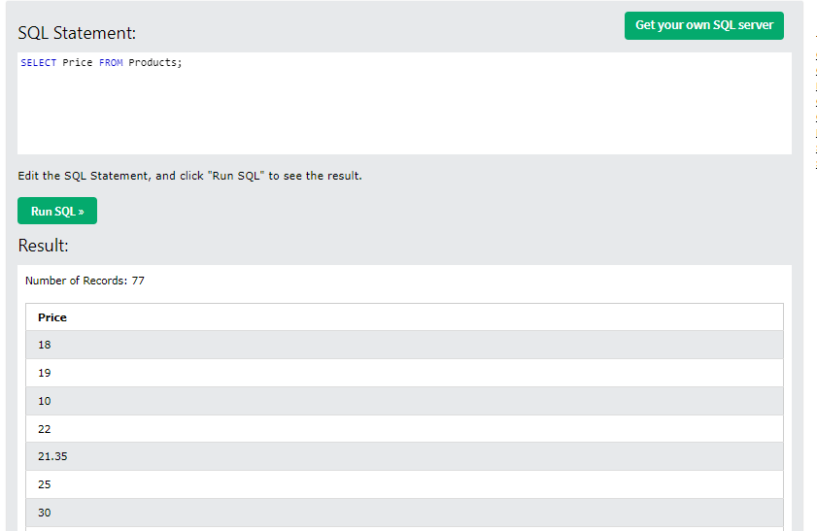

#### **After using SUM()**

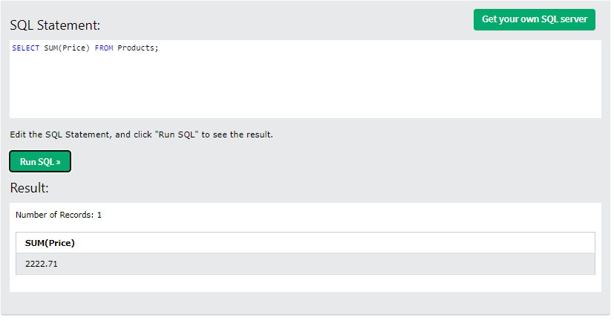

## Like

### The LIKE operator is used in a WHERE clause to search for a specified pattern in a column.

There are two wildcards often used in conjunction with the LIKE operator:

* The percent sign (%) represents zero, one, or multiple characters
* The underscore sign (_) represents one, single character
* Both of these wildcards can be combined to fetch a specific data

**I will fetch columns if the country starts with letter “G”.**

#### **Before using LIKE()**

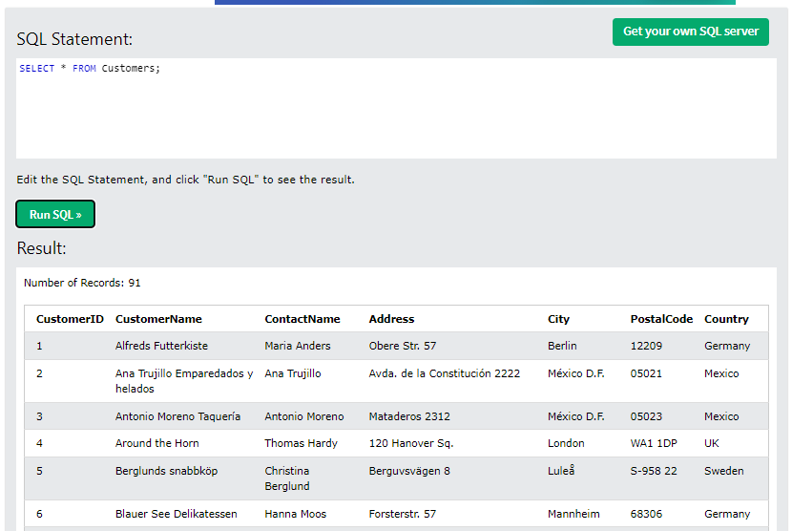

#### **After using LIKE()**

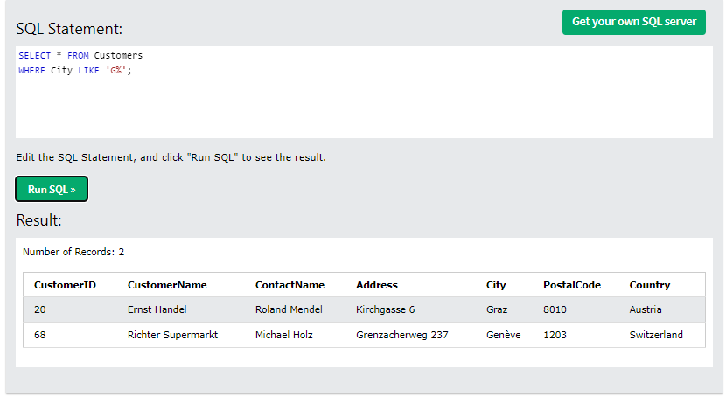

## In

### The IN operator allows you to specify multiple values in a WHERE clause.

The IN operator is a shorthand for multiple OR conditions.

**I will fetch only fetch columns if their city is one of the these following: London, Strasbourg, Munchen.**

#### **Before using IN()**

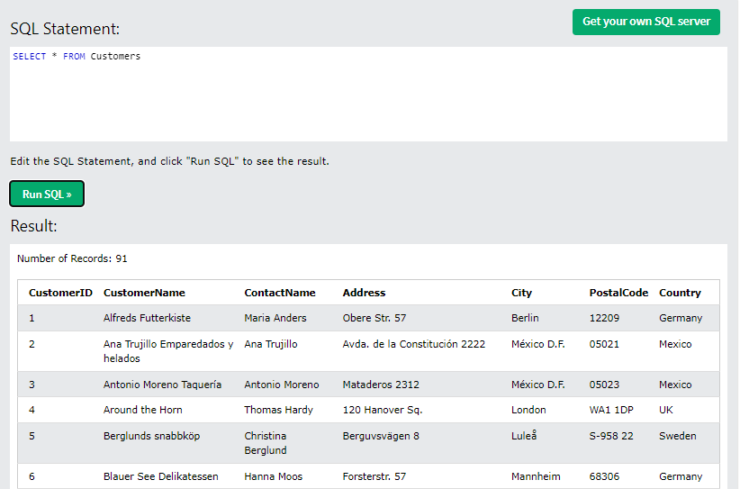

#### **After using IN()**

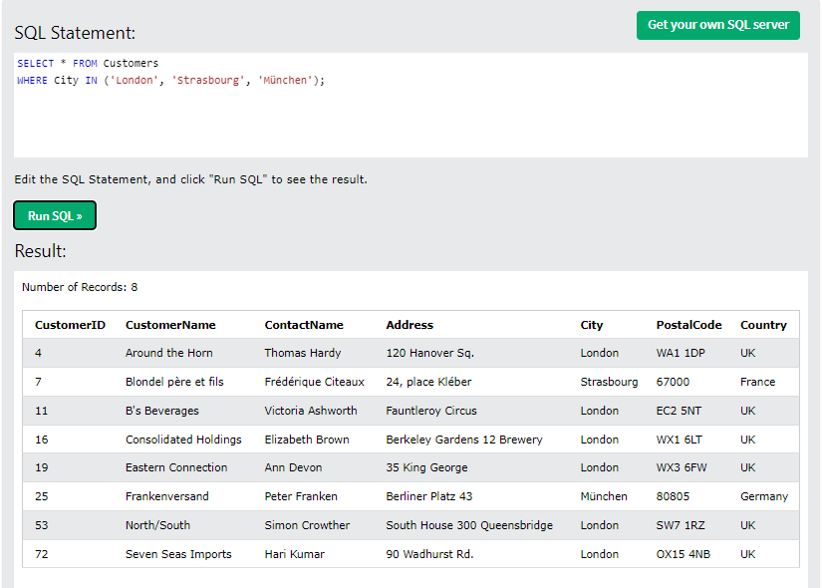

## Between

### The BETWEEN operator selects values within a given range. The values can be numbers, text, or dates.

The BETWEEN operator is inclusive: begin and end values are included.

**I will fetch only fetch columns if the supplier id is in between 3 to 4.**

#### **Before using BETWEEN()**

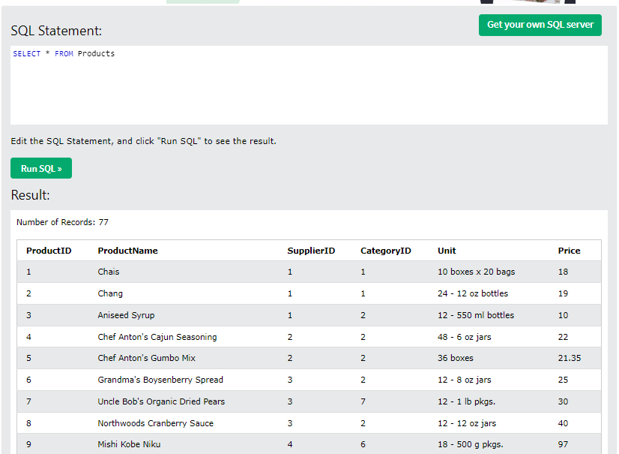

#### **After using BETWEEN()**

